**Test Exit Report**

**Project**

Web Medicine - <https://www.likar.info>

ID: WebMedicine_001. Date: 01.12.2021

**1. Test team**

|  |  |  |
| --- | --- | --- |
| **Participants** | **Role** | **Role in the reporting period** |
| Alexei Revenko  [alexeirevenko@gmail.com](mailto:alexeirevenko@gmail.com) | Lead  tester | Communication with the customer and clarification the requirements.  Designing the Test plan and Test strategy.  Designing the Checklist.  Executing functional, exploratory and GUI testing.  Reporting the bugs into a Jira.  Designing the Test Result Report. |
| Viktoriya Tikhonova  [viktoriyatikhonova@gmail.com](mailto:viktoriyatikhonova@gmail.com) | Tester | Designing the Checklist.  Executing functional, exploratory and GUI testing.  Reporting the bugs into a Jira. |
| Valiantsin Hlazko  [valentinehlazko@gmail.com](mailto:valentinehlazko@gmail.com) | Tester | Requirements analysis.  Designing the Checklist.  Executing functional, exploratory and GUI testing.  Reporting the bugs into a Jira. |
| Raman Banadyseu  [ramanbanadyseu@gmail.com](mailto:ramanbanadyseu@gmail.com) | Tester | Designing the Checklist.  Executing functional, exploratory and GUI testing.  Reporting the bugs into a Jira. |

**2. Testing progress description**

The application was tested on the:

- laptop Lenovo Z70 with operating system **Windows 10** Pro version 1909 with browser0.4170.40 - Alexei Revenko

- laptop Lenovo S340 with operating system **Windows 10** Home version 20H2 with browser **Opera** 80.0.4170.40 - Raman Banadyseu

- laptop Lenovo 20182 with operating system **Windows 10** Enterprise LTSC with browser **Google Chrome** 95.0.4638.69 - Viktoriya Tikhonova

- PC (Intel Pentium CPU G32203.0 GHz, 8 Gb RAM) with operating system **Windows 10** Pro version 19041.1288 with browser **Google Chrome** 95.0.4638.69, Huawei P30 Lite (4 Gb RAM, Android 10, EMUI 10.0.0) with browser Google Chrome 95.0.4638.50 - Valiantsin Hlazko

Graphic user interface (GUI) and Exploratory testing were executed manually by black-box method.

Detailed information about the tests can be found in the document:

<https://docs.google.com/spreadsheets/d/14M4-hZBIPc2jUrOm1php_bHdPBEhViC1HaEcu5FEuQQ>

**Test level**

System testing

**Test types used**

Functional, Exploratory and GUI testing

All tests performed manually, found defects details see in Jira:  
<https://jr.it-academy.by/secure/RapidBoard.jspa?rapidView=246&projectKey=MDST27021&view=detail&selectedIssue=MDST27021-4>.

**Summary**

The application is working stably, the main functionality works, but it was detected 195 defects where:

|  |  |  |  |  |  |  |  |
| --- | --- | --- | --- | --- | --- | --- | --- |
| **Critical** | **Major** | **Highest** | **High** | **Medium** | **Low** | **Lowest** | **Minor** |
| 0 | 0 | 2 | 5 | 118 | 62 | 7 | 1 |

It was made **100%** of tests that were planned.

**Plans for next week**

N/A. If it is decided to continue our together work, we will design it.

**Risks**

No risks are expected.

**Testing timetable**

|  |  |  |  |
| --- | --- | --- | --- |
| **Full name** | **Date** | **Description** | **Duration, h** |
| Alexei  Revenko | 17.10.2021 | Designing the Test plan. | 2 |
| Designing the Test strategy. | 1 |
| 26.10.2021 | Designing the Checklist. | 4 |
| 29.10.2021 | Executing functional, exploratory and GUI testing. | 2 |
| 02.11.2021 | 2 |
| 03.11.2021 | 2 |
| 05.11.2021 | 2 |
| 09.11.2021 | 2 |
| 10.11.2021 | 2 |
| 12.11.2021 | 2 |
| 16.11.2021 | 2 |
| 17.11.2021 | 2 |
| 19.11.2021 | 2 |
| 23.11.2021 | 2 |
| 24.11.2021 | 2 |
| 01.12.2021 | Designing the Test Result Report. | 3 |

|  |  |  |  |
| --- | --- | --- | --- |
| **Full name** | **Date** | **Description** | **Duration, h** |
| Viktoriya Tikhonova | 26.10.2021 | Designing the Checklist. | 3 |
| 27.10.2021 | Designing the Checklist. | 2 |
| 30.10.2021 | Executing functional, exploratory and GUI testing. | 2 |
| 02.11.2021 | 4 |
| 06.11.2021 | 5 |
| 09.11.2021 | 2 |
| 12.11.2021 | 2 |
| 13.11.2021 | 2 |
| 17.11.2021 | 2 |
| 18.11.2021 | 3 |
| 21.11.2021 | 2 |
| 22.11.2021 | 3 |
| 23.11.2021 | 2 |
| 24.11.2021 | 3 |
| Valiantsin  Hlazko | 24.10.2021 | Designing the Test strategy | 1 |
| 26.10.2021 | Designing the Checklist. | 2 |
| 27.10.2021 | Designing the Checklist. | 2 |
| 31.10.2021 | Executing functional, exploratory and GUI testing. | 1 |
| 02.11.2021 | 2 |
| 07.11.2021 | 2 |
| 12.11.2021 | 3 |
| 14.11.2021 | 2 |
| 17.11.2021 | 2 |
| 21.11.2021 | 4 |
| 23.11.2021 | 4 |
| 24.11.2021 | 1 |
| 01.12.2021 | Designing the Test Result Report. | 1 |
| Raman  Banadyseu | 19.10.2021 | Designing the Checklist. | 2 |
| 22.10.2021 | Designing the Checklist. | 3 |
| 29.10.2021 | Executing functional, exploratory and GUI testing. | 2 |
| 09.11.2021 | 4 |
| 12.11.2021 | 3 |
| 13.11.2021 | 2 |
| 14.11.2021 | 3 |
| 16.11.2021 | 2 |
| 20.11.2021 | 2 |
| 21.11.2021 | 2 |
| 23.11.2021 | 3 |

Testing Timetable:

For the whole team

15.10.2021 - 18.10.2021 Designing the Test plan – 2 h and Test strategy – 2 h

19.10.2021 - 28.10.2021 Designing the Checklist – 18 h

29.10.2021 - 25.11.2021 Executing functional, exploratory and GUI testing – 117 h

01.12.2021 Designing the Test Result Report 4 h

**Recommendations**

We would like to recommend focusing on fixing defects with highest and major priority first (that correspond to basic functionality), pay attention to the structure of the navigation menu and the logic of its filling. In our opinion, it is unstructured and illogical as a user. The quality of the pictures of medicines is recommend to improve.

**New bugs found**

All the bugs found during testing are new

1. The most problematic areas (according to bugs priority) are the registration form, block “ВИДЕО”, block “ЭКСПЕРТЫ”, downloading images in the block «ВОПРОС ВРАЧУ» and behavior of the app on changing the screen’s width.
2. If to consider the quantity of defects: most of them are associated with inactive links or links, that lead to error 404 “Impossible to download the page” or error 410 “the page is absent” in blocks «КРАСИВОЕ ТЕЛО», «ГРИПП И ПРОСТУДА». It could happen because the pages haven’t been administrated and links are out of date.

The most important defects you can see in the table.

See at:

<https://jr.it-academy.by/secure/RapidBoard.jspa?rapidView=246&projectKey=MDST27021> .

The most important defects see below:

|  |  |  |
| --- | --- | --- |
| **ID** | **Priority** | **Summary** |
| [MDST27021-47](https://jr.it-academy.by/browse/MDST27021-47) | Highest  (2) | The different results after performing the same actions on the page <https://www.likar.info/video/> when clicked on the link to YouTube. |
| [MDST27021-297](https://jr.it-academy.by/browse/MDST27021-297) | The registration form doesn't validate the format of the email |
| [MDST27021-7](https://jr.it-academy.by/browse/MDST27021-7) | High  (5) | Unclear if the image has loaded or not after clicking on the button "ЗАГРУЗИТЬ ИЗОБРАЖЕНИЕ" in the accordion "ВОПРОС ВРАЧУ". |
| [MDST27021-112](https://jr.it-academy.by/browse/MDST27021-112) | Buttons "ВОЙТИ" and "ЗАРЕГИСТРИРОВАТЬСЯ" in the block "ОТЗЫВЫ" on pages with medicine descriptions leads to the page with error message |
| [MDST27021-133](https://jr.it-academy.by/browse/MDST27021-133) | All the doctors that appeared after clicking on the UI button "ЗАГРУЗИТЬ ЕЩЕ" have the same place of work and post on the page <https://www.likar.info/vrach/> |
| [MDST27021-254](https://jr.it-academy.by/browse/MDST27021-254) | Endless loading after clicking "ЗАГРУЗИТЬ ЕЩЕ" button on the doctors private pages |
| [MDST27021-294](https://jr.it-academy.by/browse/MDST27021-294) | Function of displaying the image next to the search results doesn't work correctly |

**Bugs statistics**

|  |  |  |  |  |  |  |  |  |  |
| --- | --- | --- | --- | --- | --- | --- | --- | --- | --- |
| **Status** | **Quantity** | **Priority** | | | | | | | |
| Critical | Major | Highest | High | Medium | Low | Lowest | Minor |
| New | 195 | 0 | 0 | 2 | 5 | 118 | 62 | 7 | 1 |
| In work | 0 | 0 | 0 | 0 | 0 | 0 | 0 | 0 | 0 |
| Fixed | 0 | 0 | 0 | 0 | 0 | 0 | 0 | 0 | 0 |
| Closed | 0 | 0 | 0 | 0 | 0 | 0 | 0 | 0 | 0 |
| Declined | 0 | 0 | 0 | 0 | 0 | 0 | 0 | 0 | 0 |

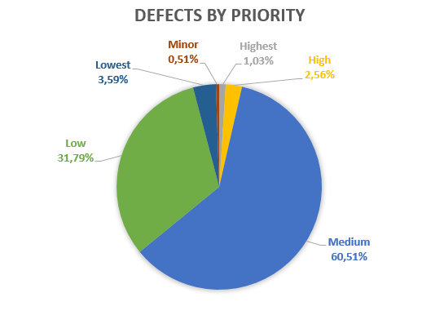

As a result of the testing process, it can be concluded that the largest number of bugs come to the “ЗДОРОВЬЕ ВСЕЙ СЕМЬИ” block in the “КРАСИВОЕ ТЕЛО” item from navigation bar. This block accounts for 44 bugs out of 195**.**

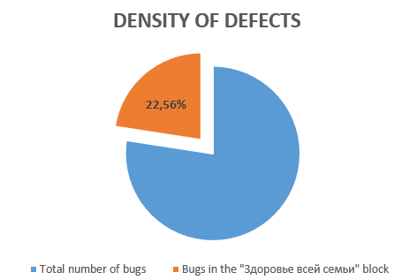

**Density of defects = number of bugs in the block/total number of bugs**

In our case density of defects is 0,23. And the number of bugs in the block reaches 22,56 %.

In this block, the proportion of defects is above average. It’s mean that this block is the most problematic.

So, “ЗДОРОВЬЕ ВСЕЙ СЕМЬИ” block should be taken into increased attention next time.

